**Sprint 2 Status Report**

# Product Demo

<https://youtu.be/O5yeH4EwrdY>

# Build Status

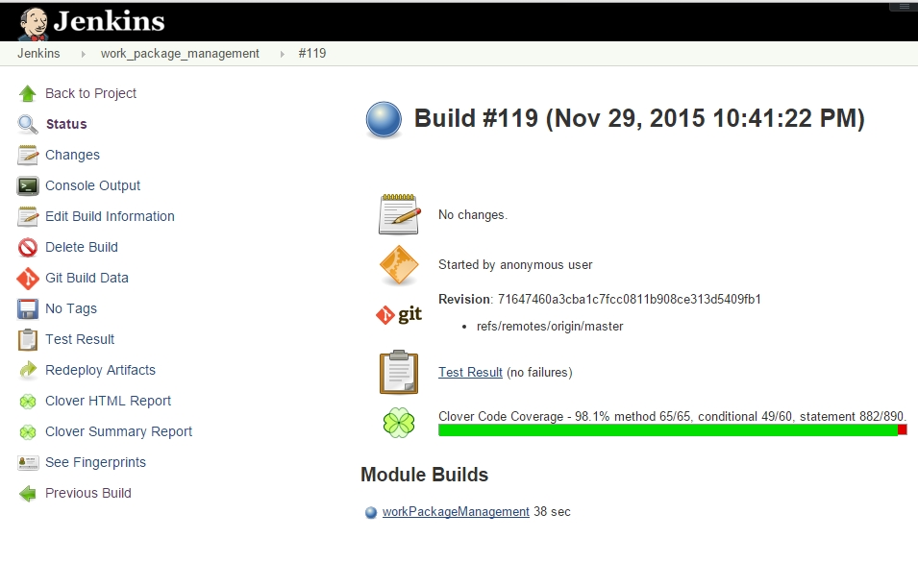

# Code Coverage

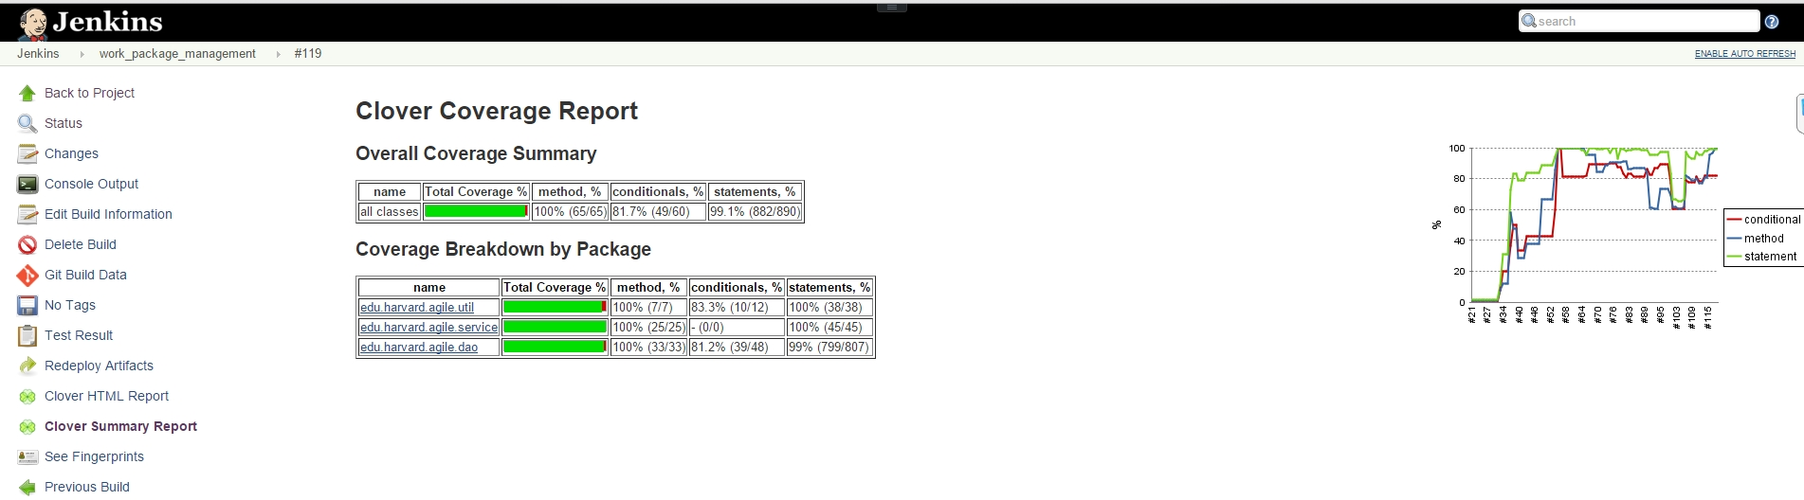

# Unit test results

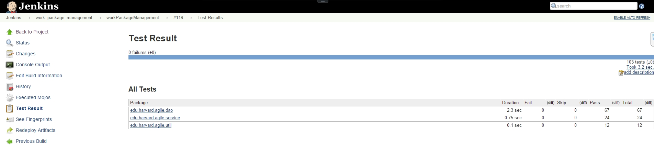

# Burn down chart

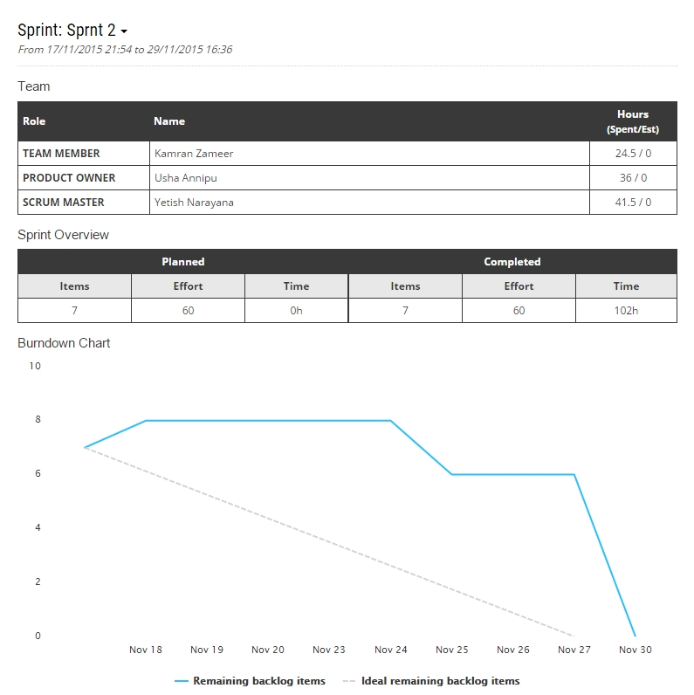

# Backlog Items

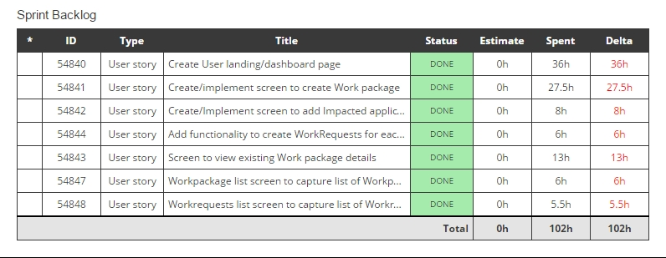

# Stake Holder feedback

* WorkPackage detail screen should be made more presentable
* Dollar amount should be preceded with a ‘$’ sign in all screens
* It is not required to show Application name in WorkRequests list screen.